Home learning
Topic We are all different
During these two following weeks our focus book is “The rainbow fish” by Marcus Pfister is a book about a unique fish with shimmering scales. Other fish admire him and request some of his scales because they want to share in his beauty. At first, the Rainbow fish didn’t want to share his scales but eventually he will share them and he will enjoy sharing his scales with the others.
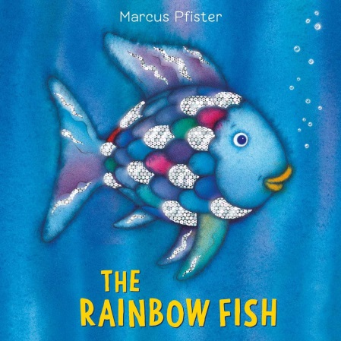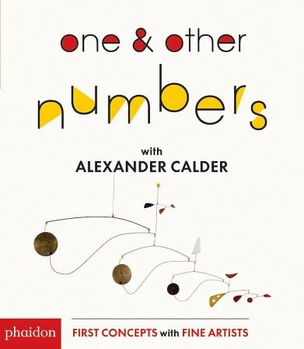

We will also continue learning about Calder his life and his lovely sculptures. We will continue to learn and explore about different shapes and primary colours using his pictures.
Skills to focus
-Cutting skills through different activities: cutting squares and rectangles like Calder and make a picture with them.
-Guided drawing https://www.youtube.com/watch?v=QtGeB5tu2xU
- Draw a picture of a fish and write kind words inside.
- Play games where you can talk about more and less
- Sort two different kinds of objects. Could you count them carefully? What group has more/less objects? Can you recognise and write the number?
-Practice to write your name when you finish a picture.
- Learn a new song and try to follow the rhythm with a instruments or a objects (two spoons, two blocks)
-Talk about the importance of sharing. How do you feel when you share? How do you feel when someone doesn’t want to share with you?

