Year 6 Spelling, Grammar and Punctuation Guidance

All children should be completing the D questions. Then, all children should be at least attempting the E questions. Not all children will complete the E questions but they should try their best to complete as many as they can. The GD questions are aimed at children who complete all of the D and E questions, but are still looking for extra challenges. Anyone who tries the GD questions should try their best to complete as many questions as they can.
If your child cannot complete the D questions, do not hesitate to contact your teacher.

Year 6 Grammatical Terms

Noun - a person, place or thing (table, chair, house, cat)
Proper Noun – the name of a person place or thing. Always with a capital letter (Mowgli, London, Chestnuts)
Verb - a doing, action or being word (to run, to make, to have, to be)
Adjective – describes a noun (superb, menacing, huge)
Adverb – describes a verb (quickly, cautiously)
Preposition – A word that describes the relationship and location of one thing to another (on, behind, after, under)
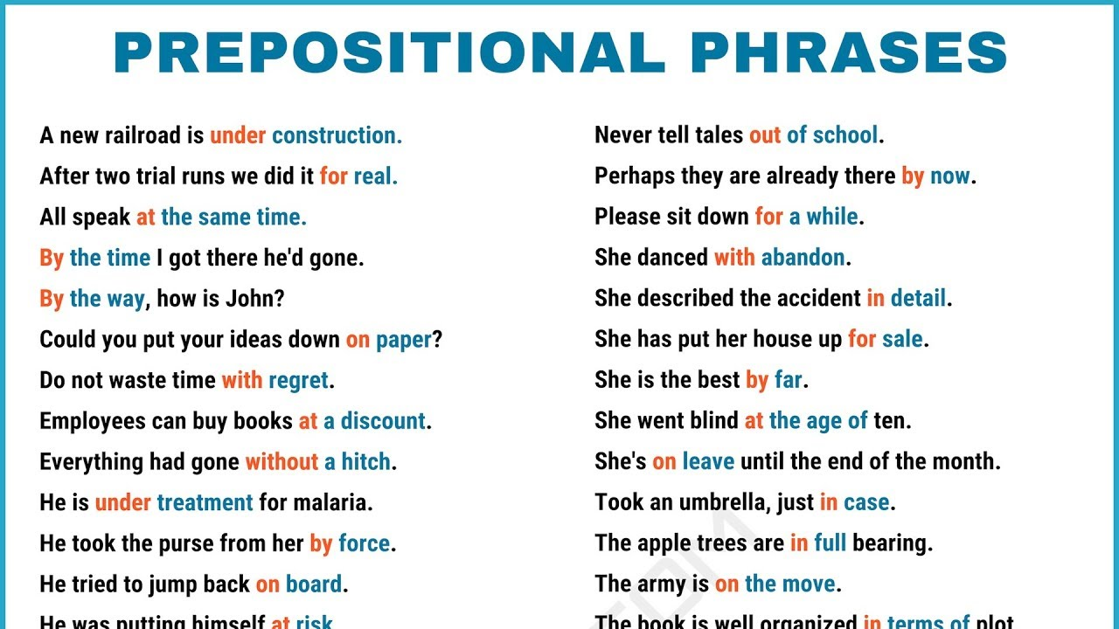
Determiner – a word that introduces a single noun or plural nouns (a, an, the, every)
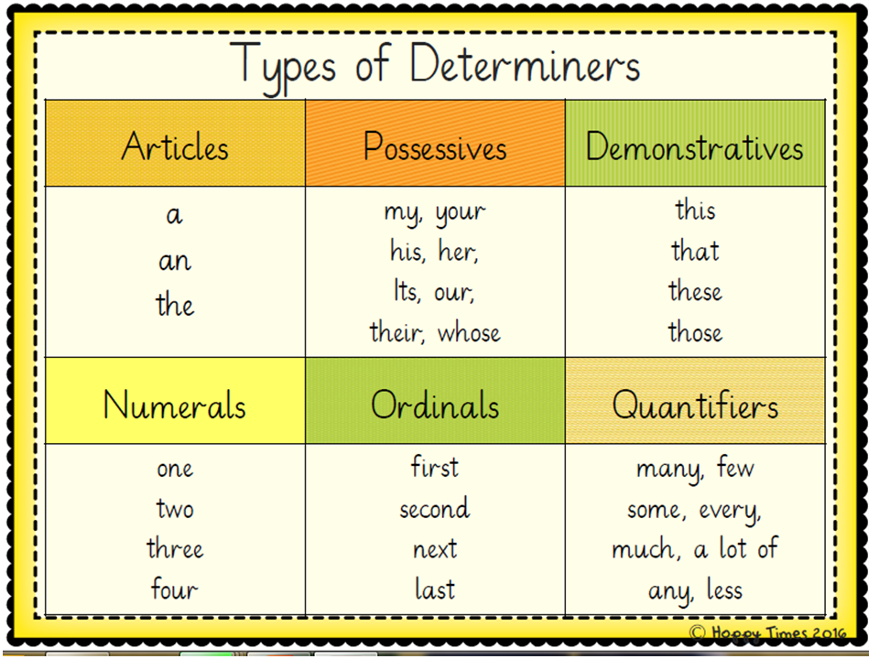
Conjunction – a word that connects two parts (clauses) of a sentence. These can be co-ordinating (and, but, yet) or subordinate (because, when, although)
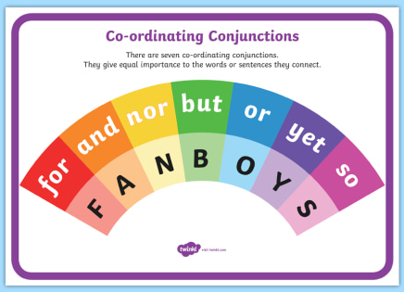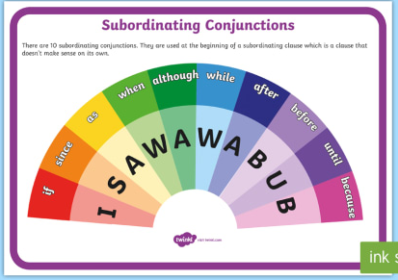

Subject & Object – In a simple sentence the person or thing performing the action is the subject of the sentence. The person or thing receiving the action is the object of the sentence.
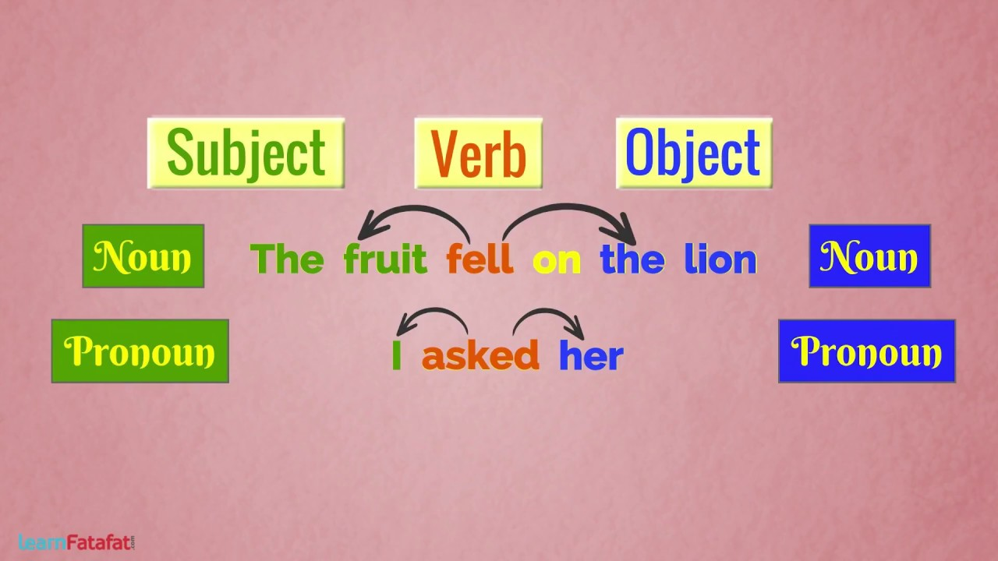
Active voice – Sentences written in the active voice have the subject placed before the object. E.G The boy kicked the ball.
Passive voice – Sentences written in the passive voice have the object placed before the subject. E.G The ball was kicked by the boy.
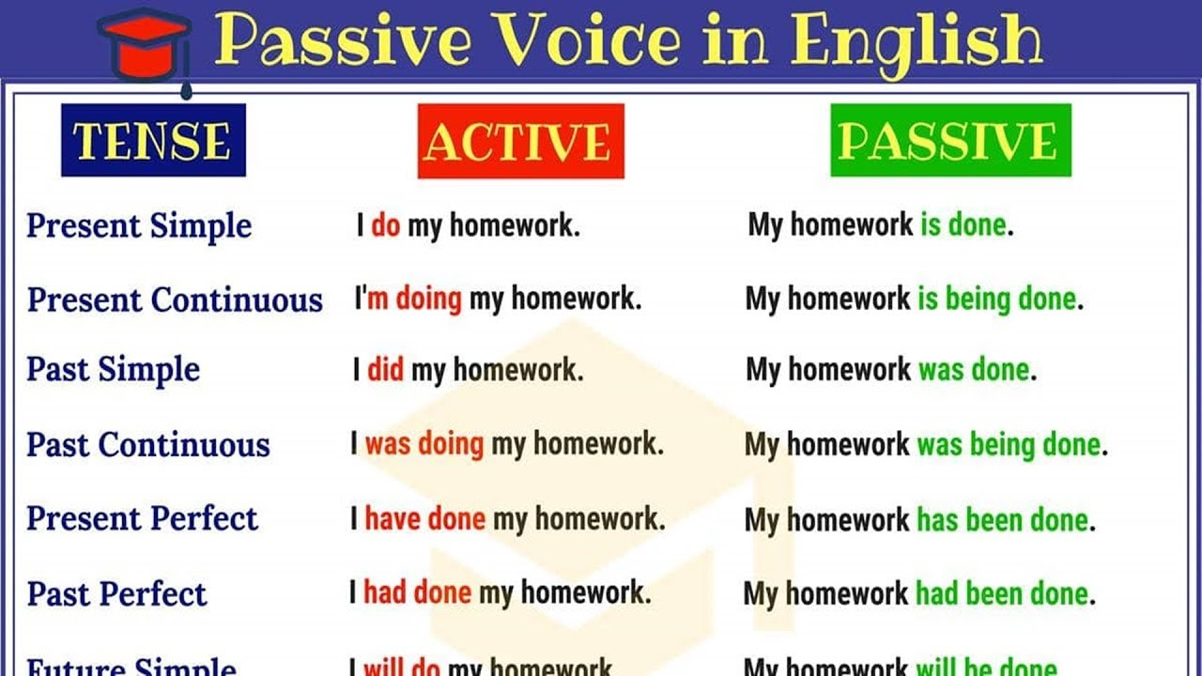
Expanded Noun phrase - sentences that use one or more adjectives to describe a noun. A noun phrase would be: ‘The giant roared.’ An expanded noun phrase would be: ‘The huge, fearsome giant roared.’
Subjunctive Form- Uses the verb form ‘were’. E.G If I were you, I would bring a coat.
Modal verbs- Indicate possibility. E.G could, might, should, can
Progressive Tense- Used to show an ongoing action in the past, present or future. E.G
Past Progressive- I was running, Present Progressive- I am running, Future Progressive- I will be running.
Perfect Tense- Used to show an action that has been completed at a certain point in time. E.G
Past Perfect- I had been to the park, Present Perfect- I have been to the park, Future Perfect- I will have been to the park.
Year 6 Punctuation Terms
Parenthesis- punctuation which is used to give extra information to a sentence, shown with either a pair of brackets, dashes or commas.

Hyphen – Joins two words together to form a compound adjective E.G Man- eating shark

Dashes/Semi colons/Colons- Used to show the boundaries between independent clauses in a sentence. Colons can also be used to show items in a list.

Apostrophes- Used to show possession or contraction. E.G Apostrophes for possession- William’s house. Apostrophes for contraction- I would’ve been late.
